## Aerodynamic Design

* + 1. Introduction:

Before designing the vehicle, goals, mission and constraints must be defined well to achieve the highest performance and efficiency.

Mission:

Flying taxi should takeoff as a quad-copter. When it gains the required and safe altitude, the flying taxi starts the quad-plane phase by turning the pusher on to achieve the required cruise speed which is specified from range, endurance and available power considerations. The flying taxi continues its quad-plane phase until it’s near from the landing point, it switches to the quad-copter mode and gradually lowering its altitude with visual odometry generated to aid the GPS for accurate position estimation and the obstacle avoidance algorithm is on to guide the flying taxi through a safe path to the landing point.

Constraints:

1. Max. takeoff weight about 3 Kg.

* Where preliminary weight estimation of vehicle contains components about 2.8 Kg.

1. Max. wide of vehicle 0.8 meter.

* This constraint has been selected to satisfy mission, be easy to manufacture and to suit the wind tunnel width for future work in testing.

1. Minimum length for easy landing at any place.

## XFLR5 program is chosen to design and analyse the aerodynamic parts of the flying taxi starting from airfoil design to the stability analysis of the complete plane.

* + 1. Wing configuration

There are a lot of wing configuration but the suitable configuration for our vehicle constraints and mission should be chosen. Since one of the important constraint of the flying taxi is to have small size, small span constraint should be achieved with generating the required lift so tandem wing plane is preferred to be used to get greater lift than conventional wing, as it has two independent source of lift (two wings) to be able to manage the takeoff weight.

Design parameters of Tandem wing plane:

1. Stagger ():

The distance between main wing and second wing at a position of .

1. Gap ():

The vertical distance between main and second wings.

1. Decalage ():

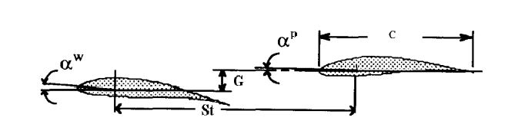The relative angle of attack between two angles of attack for each wing.

* + 1. Design Criterion
       1. Airfoil selection

In this section there is two constraints:

1. The thickness of the standard foam sheets (in some cases it was little than the camber of the airfoil)
2. Highly cambered airfoils are difficult to be manufactured using foam cutter machine (less accuracy).

The selection of the Airfoil should consider these constraints along with the requirements. xflr5 program has a built-in library of NACA series, but another airfoils can be imported.

First, airfoils that have high lift and low Reynold number; such as (Eppler421, Eppler423, MH14, NACA0018, NACA0015, Clark(Y) and NACA632615) are analysed, then suitable airfoil is chosen according to the previously stated constraints and requirements. So the airfoils that satisfy requirements are:

Eppler423 (higher lift)

NACA0015 (easy to manufacture)

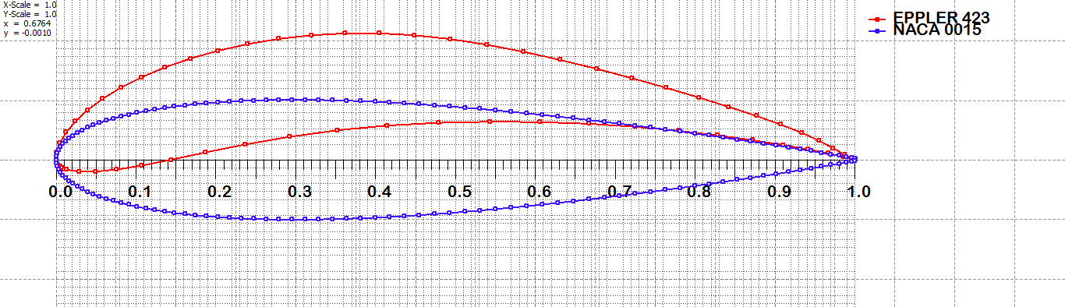The two airfoils are analysed using panel method with 150 panel for smooth results.

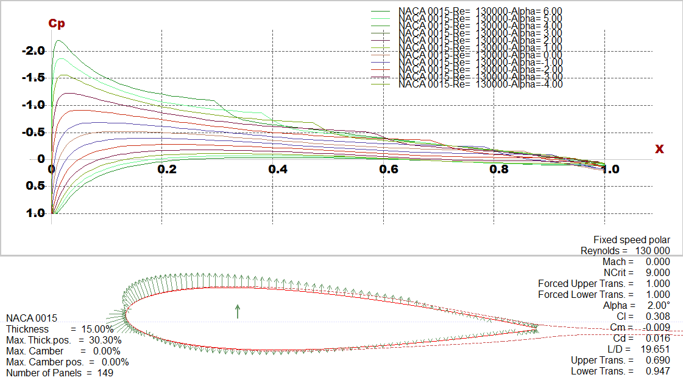Shown below the boundary layer thickness and pressure distribution along the two selected airfoils with change at angle of attack from:  
 (0 to 6 & 0 to -4 ) degree:

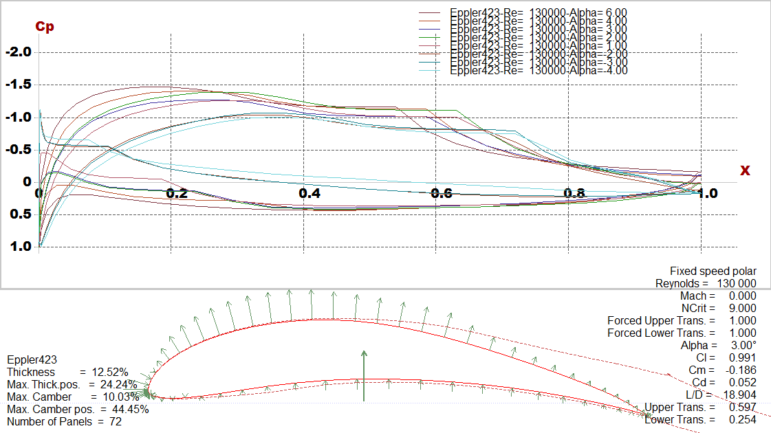Pressure distribution along NACA0015 with difference angle of attack

Pressure distribution along Eppler423 with difference angle of attack

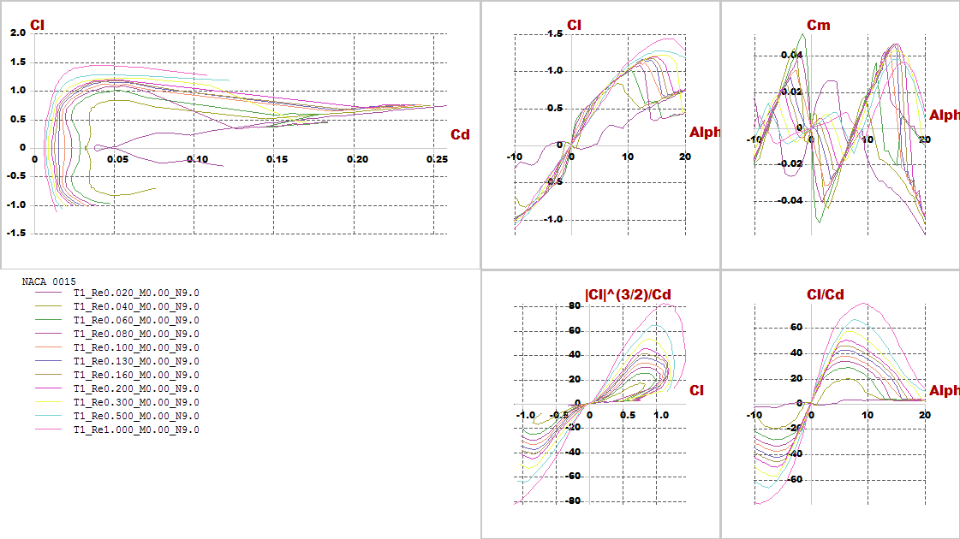We make analysis at different Re (from 20,000 to 1,000,000) and see plots on polar figure:

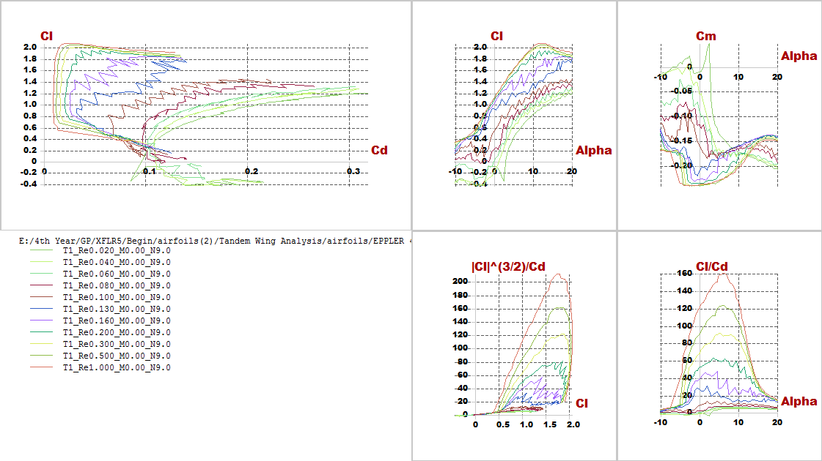Polar graph of NACA0015 with difference Reylonds number

Polar graph of Eppler423 with difference Reylonds number

* + 1. Aerodynamic analysis:

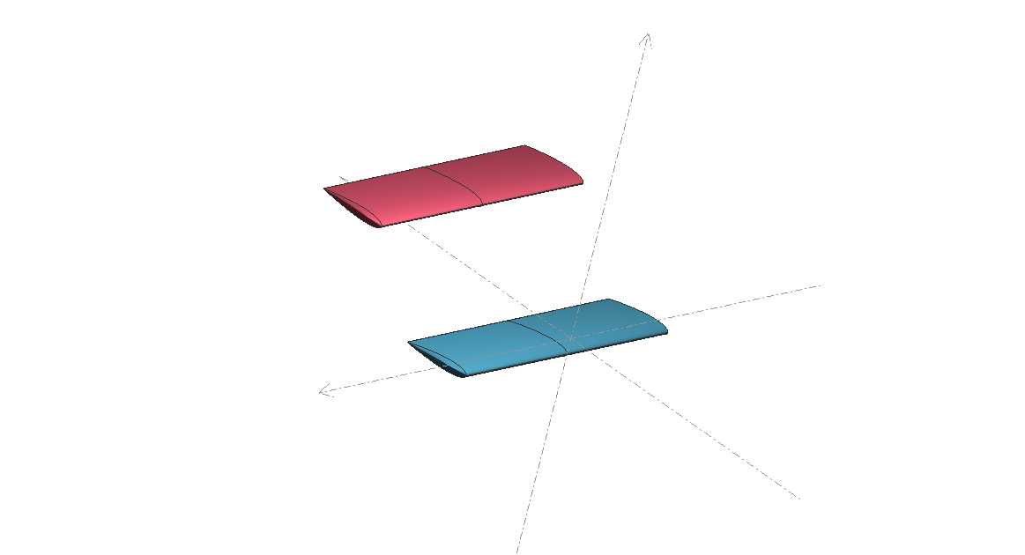Now after choosing airfoils, the wing will be designed. After trying different trials considering constraints and requirements, the best configuration has been chosen then stability and lift produced is checked.

* + - 1. Investigating goals and requirements
* 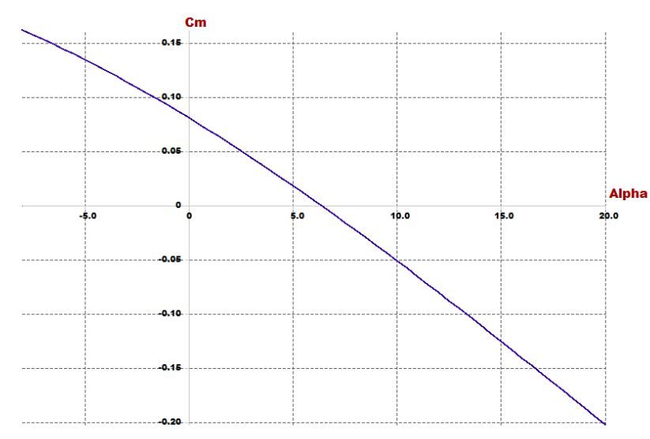For stability:
* 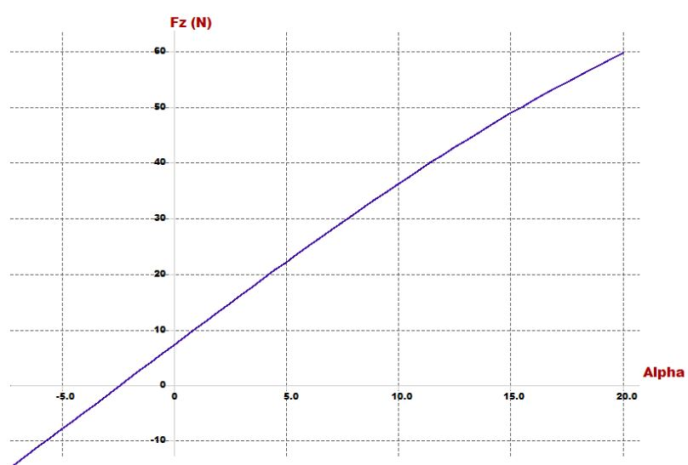For lift: At trim angle the lift must carry the vehicle
  + - 1. Design parameters

In this part stability of quad-plane is checked and the airfoil design parameters (incidence angle, CG position, cruise speed and dimensions of wings) is chosen

|  |  |
| --- | --- |
| **Parameter** | **Effect on the vehicle** |
| Span | proportional with lift |
| Chord | proportional with lift |
| Cruise speed | proportional with lift |
| Arm | Static stability |
| Incidence angle | Static stability |
| Position of CG | Static stability |
| Position of second wing | Static stability |

* + - 1. Results:

1. Model 1: (NACA0015)

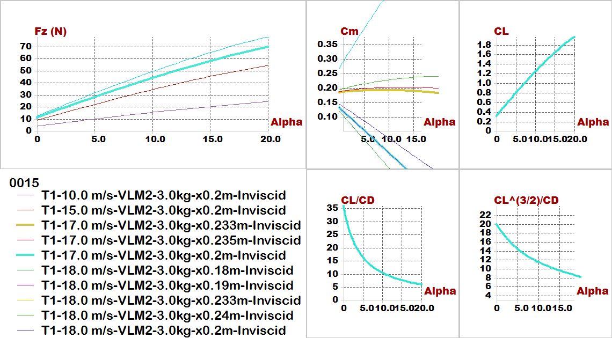

1. 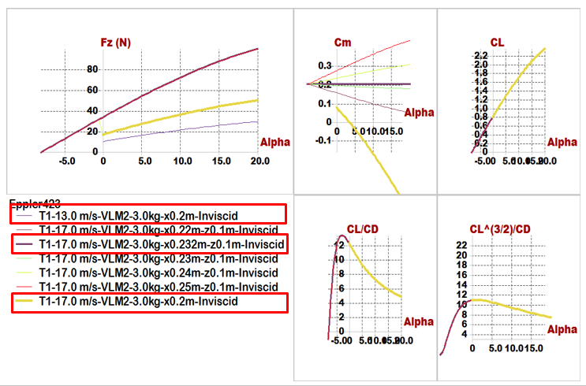 Model 2: (Eppler423)

Quick comparison between 2 airfoils:

|  |  |  |
| --- | --- | --- |
| **Comparisons \ Models** | **Model 1 (NACA0015)** | **Model 2 (Eppler423)** |
| **Position of Main wing** | x= 0  z= -0.05 m | x= 0  z= -0.05 m |
| **Position of Second wing** | x= 0.45 m  z= 0.1 m | x= 0.45 m  z= 0.15 m |
| **Span** | 0.8 m | 0.6 m |
| **Chord** | 0.25 m | 0.2 m |
| **Aspect ratio** | 3.2 | 3 |
| **Cruise speed** | 17 m/s | 17 m/s |
| **Incidence of Main wing** | 5 degree | 3 degree |
| **Incidence of Second wing** | 2 degree | -8 degree |
| **Trim angle** | 5.1 degree | 3.6 degree |
| 𝑿_𝑪.𝑮 | 0.19 m | 0.2 m |
| 𝑿_𝑵.𝑷 | 0.233 m | 0.25 m |
| **Degree of Static Stability (S.M.)** | 17.2% | 25% |

**Conclusion of results:**

1. **For configuration:**
2. Before there is illustration of the main reason to select tandem wing plane to get greater lift than conventional wing, because we have two independent source of lift (two wings).
3. Then now we can say the reason of vertical distance (Gap) between 2 wings that can affect the resulting vortex and vortex interactions that the wing spacing has a noticeable effect on the resultant flow field and aerodynamic forces, finally we selected this distance to prevent wings from weak as a wing spacing is decrease, vortex structure at last wing became elongated and spread due to interactions with the front wing.
4. Difference at dimension between 2 wings to equivalent to moment results from wings.

So this configuration help to more stable quad-plane that increase stability due to wing spacing.

1. **For incidence angle:**

All models have been built it before almost of them have a negative incidence angle for tail not exceed -3 degree, So highlighting at the incidence of second wing in two models; in model (1) has a positive incidence angle, And model (2) has a large negative incidence angle.

1. **For Static margin:**

That known the S.M. must be (from 5 to 20 %), and the S.M. in model (1) is 17.2 that is acceptable range, but at model (2) has 25%.

1. **For Lift:**

We find trim angle of attack at 5.1 degree, and we go to Fz VS Alpha graph get lift that carry aircraft we get Fz=28.8(N) at 5.1 degree, which carry 2.93 Kg maximum tack-off weight, all of calculations reference to 2.7 Kg maximum tack-off weight.

**So, we select model (1) because model (1) is more effective than model (2)**

* + 1. Optimization for aerodynamic stability:

In this phase trying to put point of C.G. in the middle of the vehicle to equalize the value of moments resulting from two wings to optimize the (𝐶𝑚−𝛼) graph, PX4 requirements, easy to manufacturing and high accuracy results during assembly.

First making several trails with constraints of stability:

1. Selected parameters which allowed to change them.
2. Then set parameters constant and change one of them, to convert slope of stability from positive to negative slope.
3. Concluded variables that affect the slope:
4. Arm.
5. The height of second wing
6. Incidence of angles of 2 wings
7. Geometry of 2 wings specially wing chord
8. Put position of C.G. and the arm, then change variables.

In this part the design parameters will be reduces to 6 parameters replacement 7 parameters, because of constant position of CG.

|  |  |
| --- | --- |
| **Parameter** | **Effect on the vehicle** |
| Span | proportional with lift |
| Chord | proportional with lift |
| Cruise speed | proportional with lift |
| Arm | Static stability |
| Incidence angle | Static stability |
| Position of second wing | Static stability |

By trial and error after fail some trails we get the best configuration by change parameters:

|  |  |
| --- | --- |
| **Comparisons \ Models** | **Model (NACA0015)** |
| **Position of Main wing** | x= 0 , z=0 |
| **Position of Second wing** | x= 0.6 m , z= 0.3 m |
| **Span of main wing** | 0.6 m |
| **Span of second wing** | 0.75 m |
| **Chord of main wing** | 0.2 m |
| **Chord of second wing** | 0.22 m |
| **Aspect ratio** | 3.2 |
| **Cruise speed** | 18 m/s |
| **Incidence of Main wing** | 3 degree |
| **Incidence of Second wing** | 2 degree |
| **Trim angle** | 6.7 degree |
| 𝑿_𝑪.𝑮 | 0.36 m |
| Z_𝑪.𝑮 | 0.15 m |
| 𝑿_𝑵.𝑷 | 0.383 m |
| **Degree of Static Stability** **(S.M.)** | 11.5% |
| **Reylonds number** | About (100,000 to 200,000) |

* + - 1. Final results:

1. 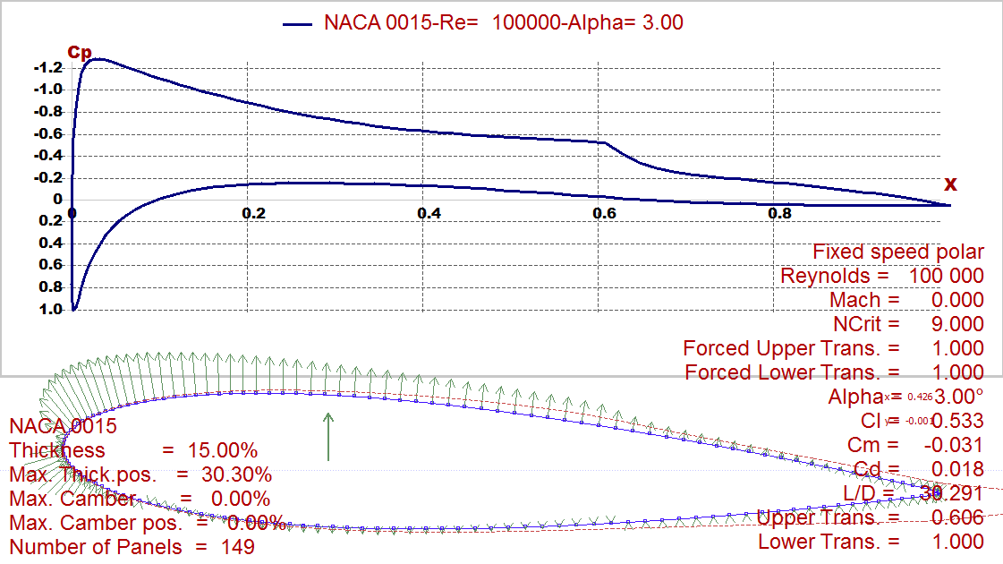Foil characteristics:

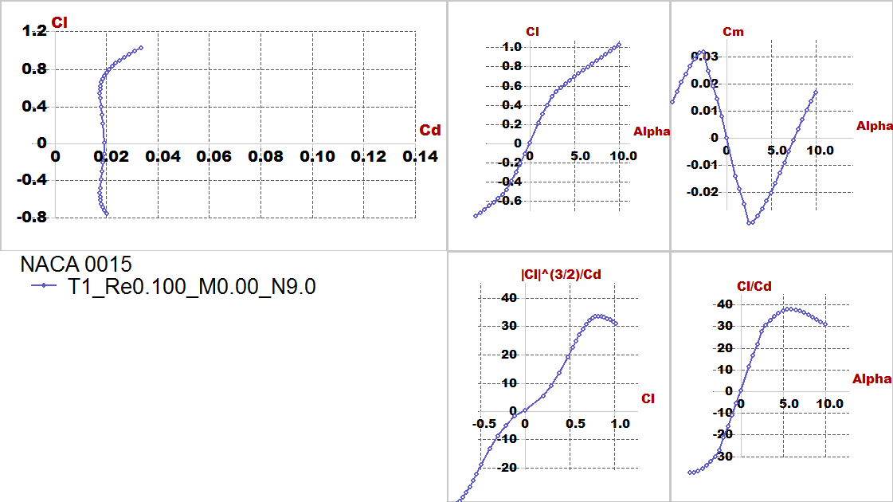Pressure distribution along NACA0015 at certain angle of attack=() And certain Reylonds number=100,000

Polar graph of NACA0015 at a certain Reylonds number=100,000

1. 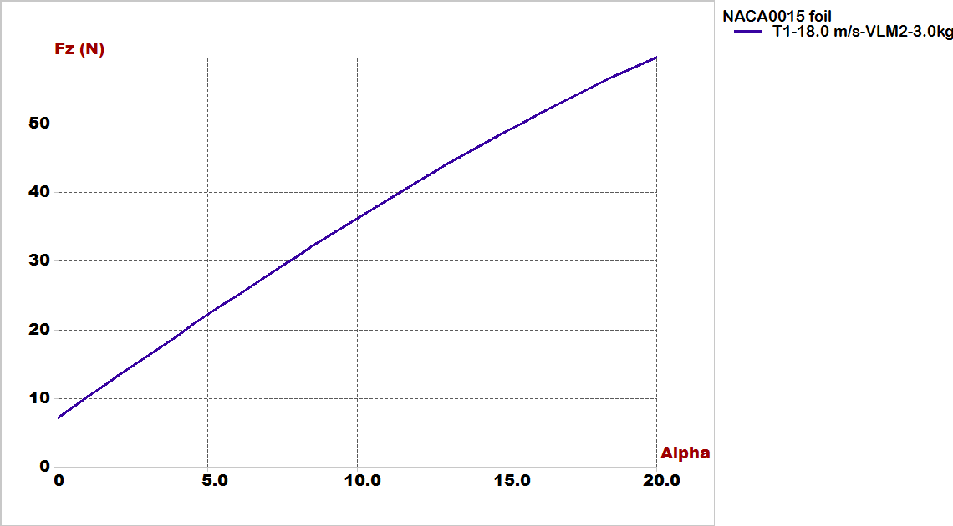Lift Vs alpha:
2. 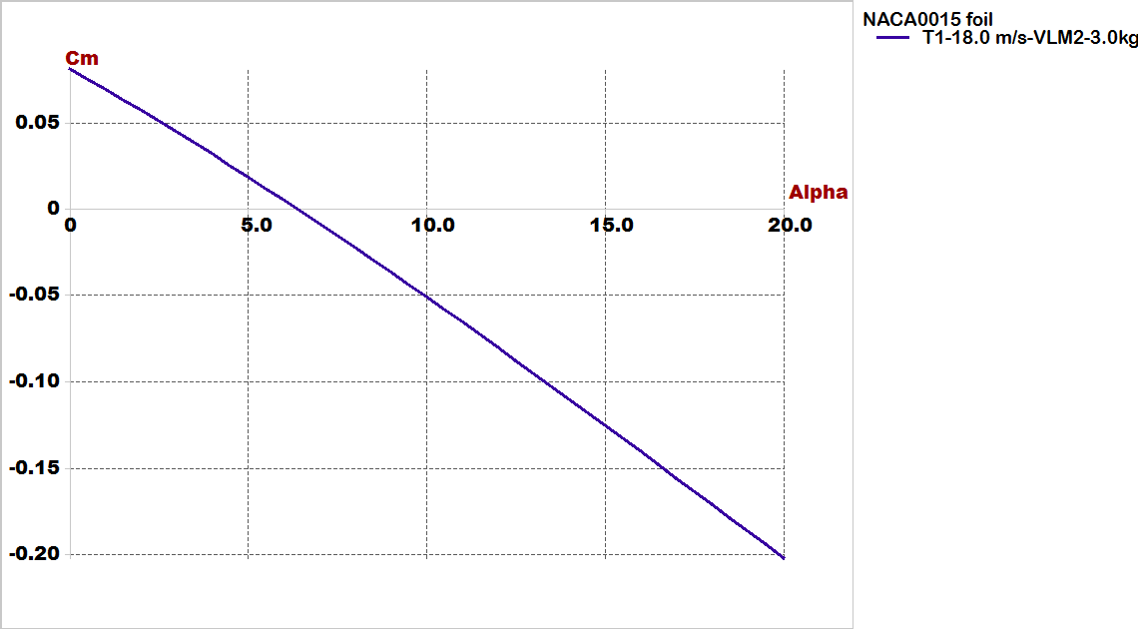Cm Vs alpha:
3. 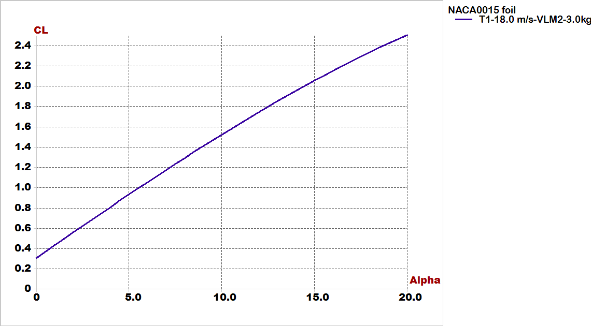Cl Vs alpha:
4. 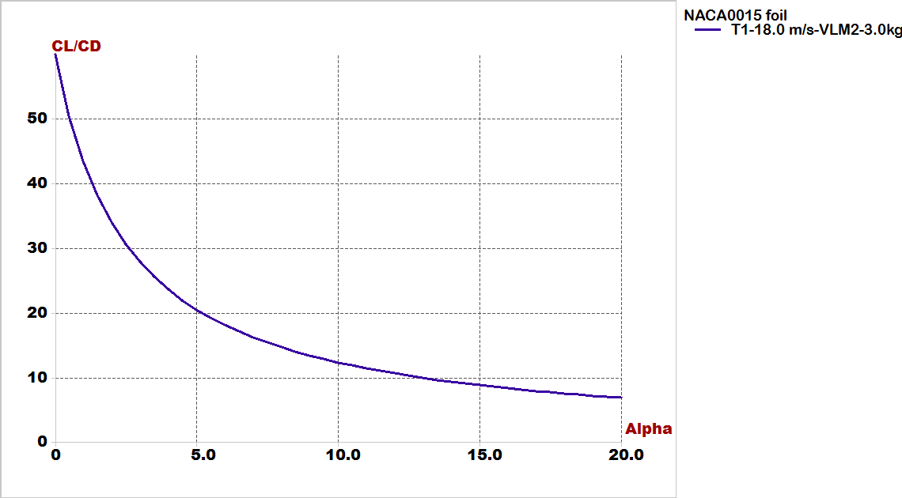Cl/Cd Vs Cd:
5. 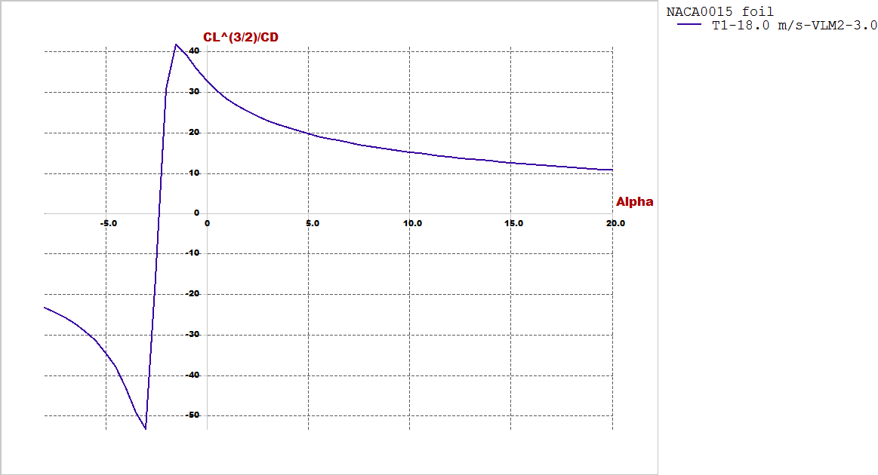Cl^(3/2)/Cd Vs alpha:

Finally must check for results by focus on 2 important figures;

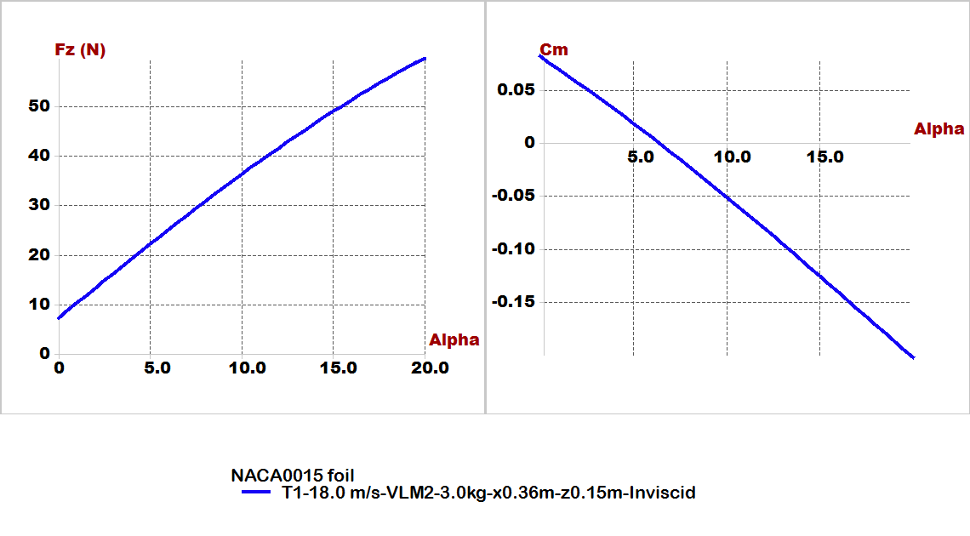(longitudinal static stability and lift generated from airfoil) ; slope of Cm Vs alpha must has negative slope, and the value of lift at trim angle of attack must be carry the weight of vehicle:

* + 1. Stability Analysis:
    2. Stability Analysis:

We will illustrate this part by video its shown modes of longitudinal and lateral stability of plane by root locus and time response

* + - 1. For longitudinal:
  1. Type1: short period mode.
  2. Type2: Pitching.
  3. 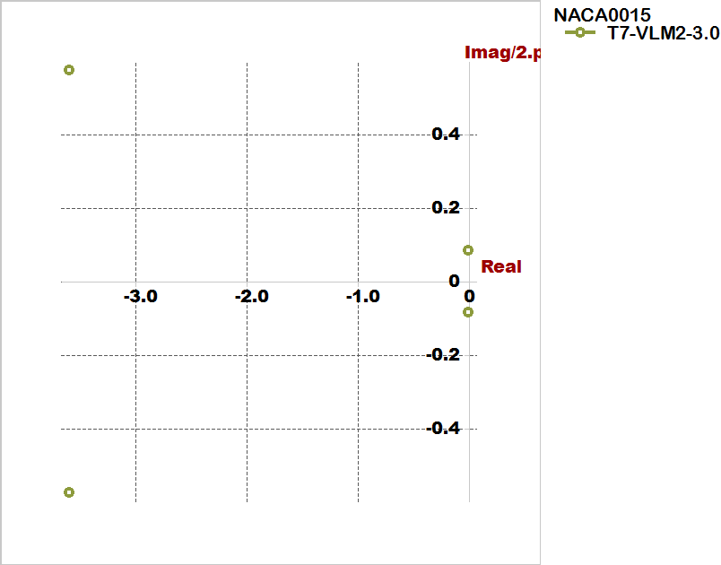Type3,4: motion around steady state flight.

Root locus view for longitudinal

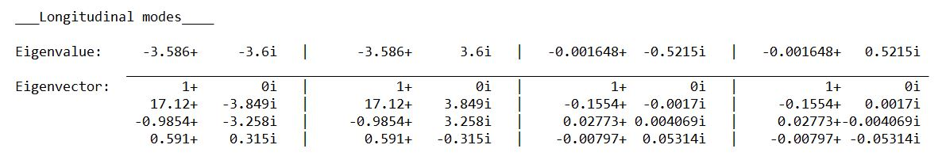

**Longitudinal derivatives from Xflr5:**

|  |  |
| --- | --- |
|  |  |
|  |  |
|  |  |
|  |  |
|  |  |
|  |  |
|  |  |
|  |  |
| Neutral Point position= 0.38245 m | |

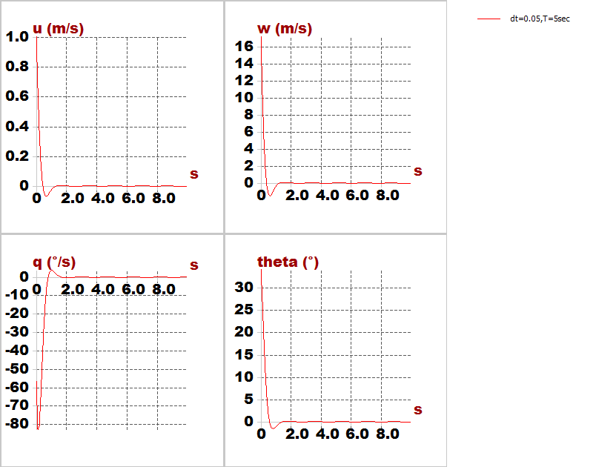**Time response characteristics:**

Short period mode

u: horizontal speed.

w: vertical speed.

q: pitch rate.

theta: pitch angle.

We noticed that is heavy damped mode (quick mode), all parameters reached to zero at very small time.

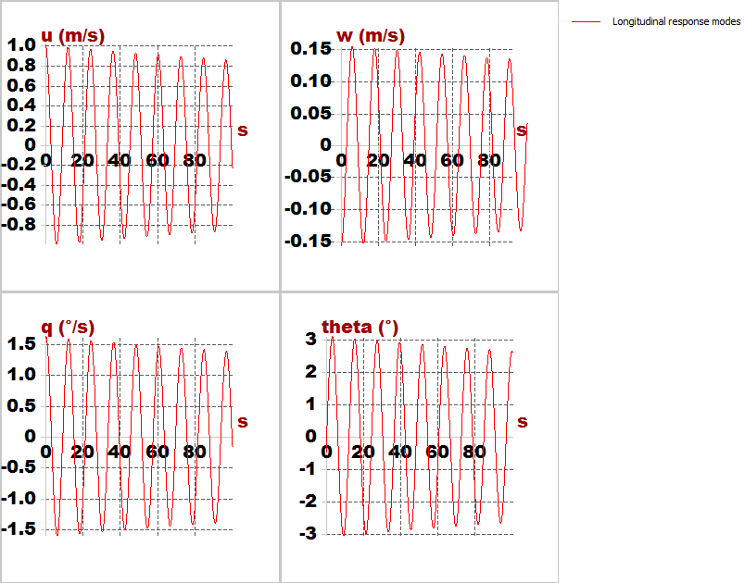

Motion around steady flight mode

At total time=100 second, and step=0.1 second we see the signal is converge with time (dynamically stable)

* + - 1. For lateral:

1. Type1: roll damping.
2. Type2,3: dutch roll mode.
3. Type4: spiral mode.

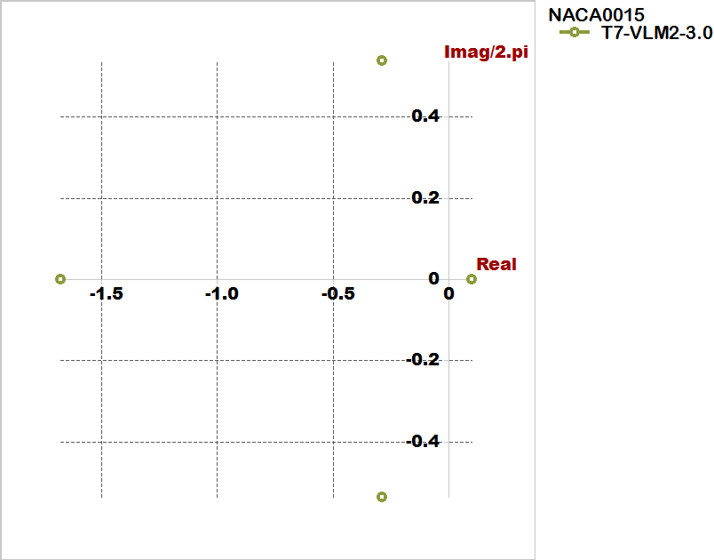

Root locus view for lateral

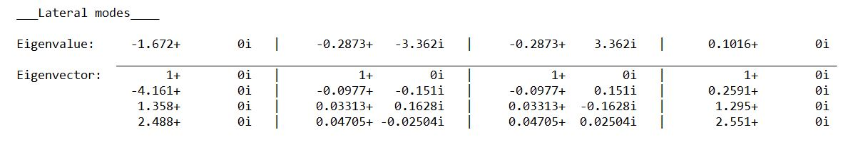

**Lateral derivatives from Xflr5:**

|  |  |
| --- | --- |
|  |  |
|  |  |
|  |  |
|  |  |
|  |  |
|  |  |
|  |  |
|  |  |
|  |  |

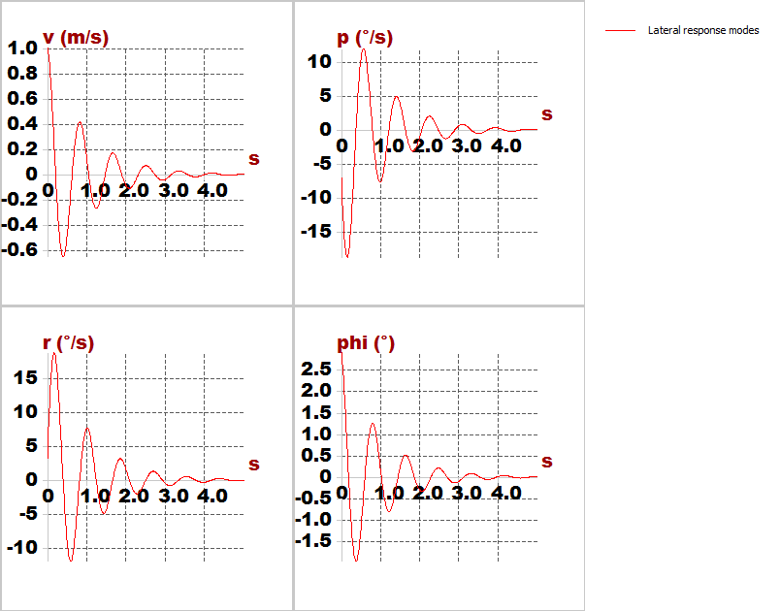**Time response characteristics:**

Lateral response modes

v: velocity speed.

p: roll rate.

r: yaw rate.

phi: bank angle.

**Non-dimensional Stability Derivatives calculated by program:**

|  |  |
| --- | --- |
| CXu = -0.12599 | CYb = -0.24520 |
| CLu = 0.00057 | Clb = -0.05277 |
| Cmu = 0.00000 | Cnb = 0.12824 |
| CXa = 0.28216 | CYp = -0.06327 |
| CLa = 6.95194 | Clp = -0.90835 |
| Cma =-0.78024 | Cnp = -0.15792 |
| CXq = -0.24026 | CYr =0.29289 |
| CLq =13.60765 | Clr = 0.38927 |
| Cmq =-42.88605 | Cnr = -0.15451 |